SQL> create table customer(id number(5),name varchar(10),address varchar(15),mobile number(11),dob varchar(7));

Table created.

SQL> desc customer;

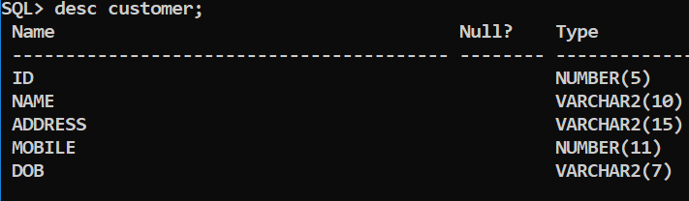

SQL> insert into customer values(&id,'&name','&address',&mobile,'&dob');

Enter value for id: 1

Enter value for name: kousi

Enter value for address: mpl

Enter value for mobile: 8008012839

Enter value for dob: 9-sep

old 1: insert into customer values(&id,'&name','&address',&mobile,'&dob')

new 1: insert into customer values(1,'kousi','mpl',8008012839,'9-sep')

1 row created.

SQL> insert into customer values(&id,'&name','&address',&mobile,'&dob');

Enter value for id: 2

Enter value for name: lakshmi

Enter value for address: brklkta

Enter value for mobile: 7993375909

Enter value for dob: 26-june

old 1: insert into customer values(&id,'&name','&address',&mobile,'&dob')

new 1: insert into customer values(2,'lakshmi','brklkta',7993375909,'26-june')

1 row created.

SQL> insert into customer values(&id,'&name','&address',&mobile,'&dob');

Enter value for id: 3

Enter value for name: anu

Enter value for address: kuppam

Enter value for mobile: 8919526623

Enter value for dob: 4-may

old 1: insert into customer values(&id,'&name','&address',&mobile,'&dob')

new 1: insert into customer values(3,'anu','kuppam',8919526623,'4-may')

1 row created.

SQL> insert into customer values(&id,'&name','&address',&mobile,'&dob');

Enter value for id: 4

Enter value for name: madhu

Enter value for address: plmnr

Enter value for mobile: 9052641989

Enter value for dob: 5-dec

old 1: insert into customer values(&id,'&name','&address',&mobile,'&dob')

new 1: insert into customer values(4,'madhu','plmnr',9052641989,'5-dec')

1 row created.

SQL> insert into customer values(&id,'&name','&address',&mobile,'&dob');

Enter value for id: 5

Enter value for name: dhana

Enter value for address: angallu

Enter value for mobile: 8919526623

Enter value for dob: 25-dec

old 1: insert into customer values(&id,'&name','&address',&mobile,'&dob')

new 1: insert into customer values(5,'dhana','angallu',8919526623,'25-dec')

1 row created.

SQL> insert into customer values(&id,'&name','&address',&mobile,'&dob');

Enter value for id: 6

Enter value for name: arun

Enter value for address: pngnr

Enter value for mobile: 6302911063

Enter value for dob: 10-aug

old 1: insert into customer values(&id,'&name','&address',&mobile,'&dob')

new 1: insert into customer values(6,'arun','pngnr',6302911063,'10-aug')

1 row created.

SQL> insert into customer values(&id,'&name','&address',&mobile,'&dob');

Enter value for id: 7

Enter value for name: naveen

Enter value for address: panjani

Enter value for mobile: 9052651989

Enter value for dob: 19-sep

old 1: insert into customer values(&id,'&name','&address',&mobile,'&dob')

new 1: insert into customer values(7,'naveen','panjani',9052651989,'19-sep')

1 row created.

SQL> insert into customer values(&id,'&name','&address',&mobile,'&dob');

Enter value for id: 8

Enter value for name: mzl

Enter value for address: mits

Enter value for mobile: 9555952593

Enter value for dob: 7-nov

old 1: insert into customer values(&id,'&name','&address',&mobile,'&dob')

new 1: insert into customer values(8,'mzl','mits',9555952593,'7-nov')

1 row created.

SQL> insert into customer values(&id,'&name','&address',&mobile,'&dob');

Enter value for id: 9

Enter value for name: cm

Enter value for address: estate

Enter value for mobile: 6302911062

Enter value for dob: 24-may

old 1: insert into customer values(&id,'&name','&address',&mobile,'&dob')

new 1: insert into customer values(9,'cm','estate',6302911062,'24-may')

1 row created.

SQL> insert into customer values(&id,'&name','&address',&mobile,'&dob');

Enter value for id: 10

Enter value for name: saba

Enter value for address: bnglr

Enter value for mobile: 8008012839

Enter value for dob: 25-may

old 1: insert into customer values(&id,'&name','&address',&mobile,'&dob')

new 1: insert into customer values(10,'saba','bnglr',8008012839,'25-may')

1 row created.

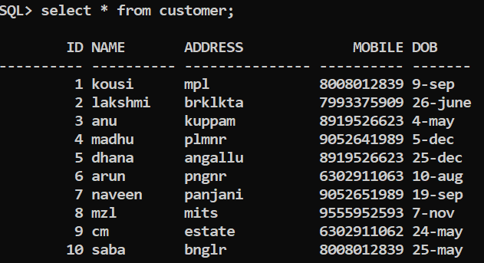

SQL> commit;

Commit complete.

SQL> create table depositor(id number(5),name varchar(10),balance number(15),mobile number(11),address varchar(7));

Table created.

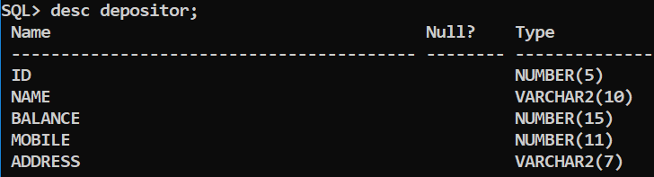

SQL> insert into depositor values(&id,'&name',&balance,&mobile,'&address');

Enter value for id: 1

Enter value for name: kousi

Enter value for balance: 50000

Enter value for mobile: 8008012839

Enter value for address: mpl

old 1: insert into depositor values(&id,'&name',&balance,&mobile,'&address')

new 1: insert into depositor values(1,'kousi',50000,8008012839,'mpl')

1 row created.

SQL> insert into depositor values(&id,'&name',&balance,&mobile,'&address');

Enter value for id: 2

Enter value for name: lakshmi

Enter value for balance: 45000

Enter value for mobile: 7993375909

Enter value for address: brklkta

old 1: insert into depositor values(&id,'&name',&balance,&mobile,'&address')

new 1: insert into depositor values(2,'lakshmi',45000,7993375909,'brklkta')

1 row created.

SQL> insert into depositor values(&id,'&name',&balance,&mobile,'&address');

Enter value for id: 3

Enter value for name: anu

Enter value for balance: 90000

Enter value for mobile: 8919526623

Enter value for address: kuppam

old 1: insert into depositor values(&id,'&name',&balance,&mobile,'&address')

new 1: insert into depositor values(3,'anu',90000,8919526623,'kuppam')

1 row created.

SQL> insert into depositor values(&id,'&name',&balance,&mobile,'&address');

SQL> insert into depositor values(&id,'&name',&balance,&mobile,'&address');

Enter value for id: 4

Enter value for name: madhu

Enter value for balance: 64000

Enter value for mobile: 9052641989

Enter value for address: plmnr

old 1: insert into depositor values(&id,'&name',&balance,&mobile,'&address')

new 1: insert into depositor values(4,'madhu',64000,9052641989,'plmnr')

1 row created.

SQL> insert into depositor values(&id,'&name',&balance,&mobile,'&address');

Enter value for id: 5

Enter value for name: dhana

Enter value for balance: 75000

Enter value for mobile: 8919526623

Enter value for address: angallu

old 1: insert into depositor values(&id,'&name',&balance,&mobile,'&address')

new 1: insert into depositor values(5,'dhana',75000,8919526623,'angallu')

1 row created.

SQL> insert into depositor values(&id,'&name',&balance,&mobile,'&address');

Enter value for id: 6

Enter value for name: swathi

Enter value for balance: 54000

Enter value for mobile: 7702198926

Enter value for address: bsnknda

old 1: insert into depositor values(&id,'&name',&balance,&mobile,'&address')

new 1: insert into depositor values(6,'swathi',54000,7702198926,'bsnknda')

1 row created.

SQL> insert into depositor values(&id,'&name',&balance,&mobile,'&address');

Enter value for id: 7

Enter value for name: paddu

Enter value for balance: 55000

Enter value for mobile: 9676759624

Enter value for address: amcrmt

old 1: insert into depositor values(&id,'&name',&balance,&mobile,'&address')

new 1: insert into depositor values(7,'paddu',55000,9676759624,'amcrmt')

1 row created.

SQL> insert into depositor values(&id,'&name',&balance,&mobile,'&address');

Enter value for id: 8

Enter value for name: issu

Enter value for balance: 99000

Enter value for mobile: 987654321

Enter value for address: krblkta

old 1: insert into depositor values(&id,'&name',&balance,&mobile,'&address');

new 1: insert into depositor values(8,'issu',99000,987654321,'krblkta')

1 row created.

SQL> insert into depositor values(&id,'&name',&balance,&mobile,'&address');

Enter value for id: 9

Enter value for name: ganesh

Enter value for balance: 77000

Enter value for mobile: 67895432

Enter value for address: rmpali

old 1: insert into depositor values(&id,'&name',&balance,&mobile,'&address')

new 1: insert into depositor values(9,'ganesh',77000,67895432,'rmpali')

1 row created.

SQL> insert into depositor values(&id,'&name',&balance,&mobile,'&address');

Enter value for id: 10

Enter value for name: likhitha

Enter value for balance: 22000

Enter value for mobile: 789654321

Enter value for address: vempli

old 1: insert into depositor values(&id,'&name',&balance,&mobile,'&address');

new 1: insert into depositor values(10,'likhitha',22000,789654321,'vempli')

1 row created.

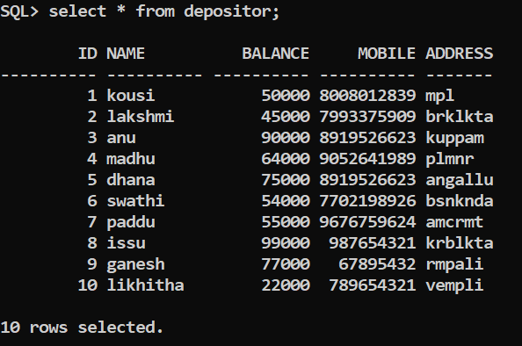

SQL> select id,name from customer union select id,name from depositor;

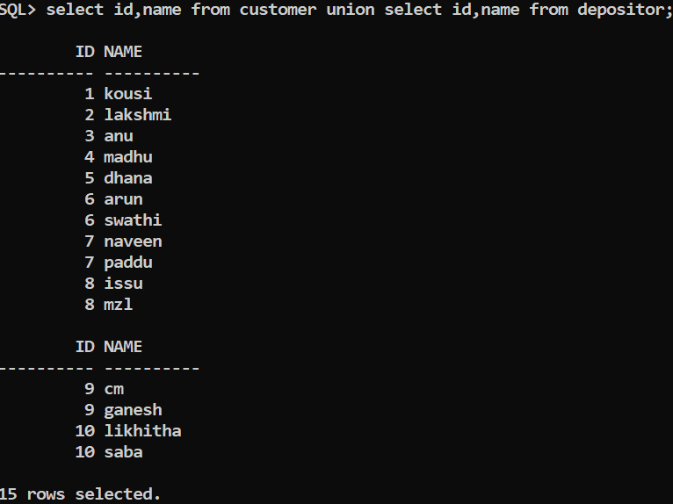

SQL> select id,name from customer intersect select id,name from depositor;

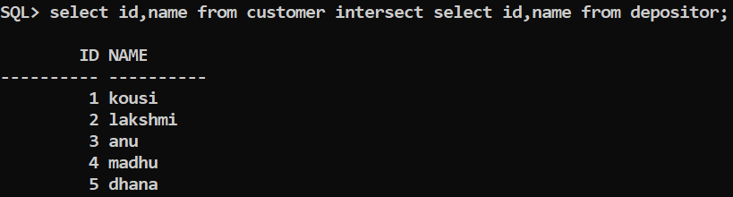

SQL> select id,name,address from customer intersect select id,name,address from depositor;

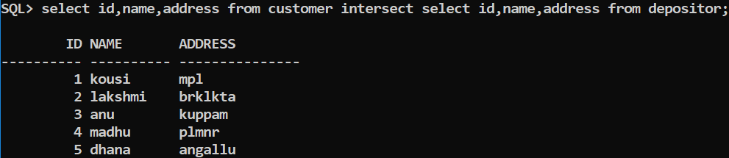

SQL> select id,name,address from customer minus select id,name,address from depositor;

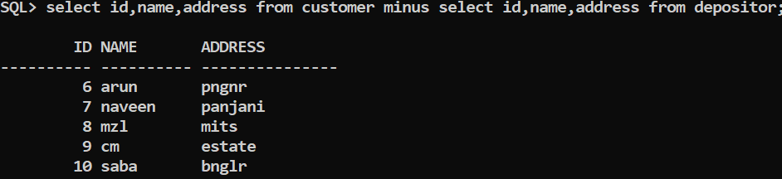

Student details

SQL> create table student(id number(2),name varchar(9),course varchar(4),location varchar(7),dob varchar(7));

Table created.

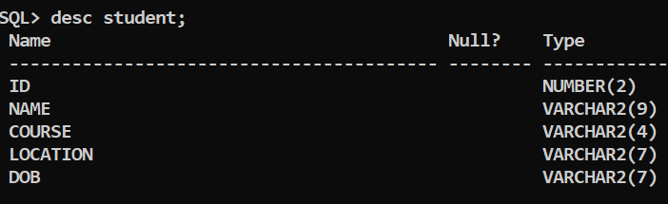

SQL> insert into student values(&id,'&name','&course','&location','&dob');

Enter value for id: 1

Enter value for name: kousi

Enter value for course: mca

Enter value for location: mpl

Enter value for dob: 19-sep

old 1: insert into student values(&id,'&name','&course','&location','&dob')

new 1: insert into student values(1,'kousi','mca','mpl','19-sep')

1 row created.

SQL> insert into student values(&id,'&name','&course','&location','&dob');

Enter value for id: 2

Enter value for name: lakshmi

Enter value for course: mba

Enter value for location: kbk

Enter value for dob: 26-jun

old 1: insert into student values(&id,'&name','&course','&location','&dob')

new 1: insert into student values(2,'lakshmi','mba','kbk','26-jun')

1 row created.

SQL> insert into student values(&id,'&name','&course','&location','&dob');

Enter value for id: 3

Enter value for name: anu

Enter value for course: mca

Enter value for location: kuppam

Enter value for dob: 5-aprl

old 1: insert into student values(&id,'&name','&course','&location','&dob')

new 1: insert into student values(3,'anu','mca','kuppam','5-aprl')

1 row created.

SQL> insert into student values(&id,'&name','&course','&location','&dob');

Enter value for id: 4

Enter value for name: madhu

Enter value for course: mba

Enter value for location: plmnr

Enter value for dob: may-5

old 1: insert into student values(&id,'&name','&course','&location','&dob')

new 1: insert into student values(4,'madhu','mba','plmnr','may-5')

1 row created.

SQL> insert into student values(&id,'&name','&course','&location','&dob');

Enter value for id: 5

Enter value for name: arun

Enter value for course: mca

Enter value for location: pgnr

Enter value for dob: 22-dec

old 1: insert into student values(&id,'&name','&course','&location','&dob')

new 1: insert into student values(5,'arun','mca','pgnr','22-dec')

1 row created.

SQL> insert into student values(&id,'&name','&course','&location','&dob');

Enter value for id: 6

Enter value for name: naveen

Enter value for course: msc

Enter value for location: panjani

Enter value for dob: 12-dec

old 1: insert into student values(&id,'&name','&course','&location','&dob')

new 1: insert into student values(6,'naveen','msc','panjani','12-dec')

1 row created.

SQL> insert into student values(&id,'&name','&course','&location','&dob');

Enter value for id: 7

Enter value for name: jyoshna

Enter value for course: mca

Enter value for location: tmblpli

Enter value for dob: 1-dec

old 1: insert into student values(&id,'&name','&course','&location','&dob')

new 1: insert into student values(7,'jyoshna','mca','tmblpli','1-dec')

1 row created.

SQL> insert into student values(&id,'&name','&course','&location','&dob');

Enter value for id: 8

Enter value for name: chandhu

Enter value for course: msc

Enter value for location: grmknd

Enter value for dob: 12-nov

old 1: insert into student values(&id,'&name','&course','&location','&dob')

new 1: insert into student values(8,'chandhu','msc','grmknd','12-nov')

1 row created.

SQL> insert into student values(&id,'&name','&course','&location','&dob');

Enter value for id: 9

Enter value for name: dhana

Enter value for course: mba

Enter value for location: angalu

Enter value for dob: 26-dec

old 1: insert into student values(&id,'&name','&course','&location','&dob')

new 1: insert into student values(9,'dhana','mba','angalu','26-dec')

1 row created.

SQL> insert into student values(&id,'&name','&course','&location','&dob');

Enter value for id: 10

Enter value for name: lavanya

Enter value for course: mca

Enter value for location: ksvpali

Enter value for dob: 16-june

old 1: insert into student values(&id,'&name','&course','&location','&dob')

new 1: insert into student values(10,'lavanya','mca','ksvpali','16-june')

1 row created.

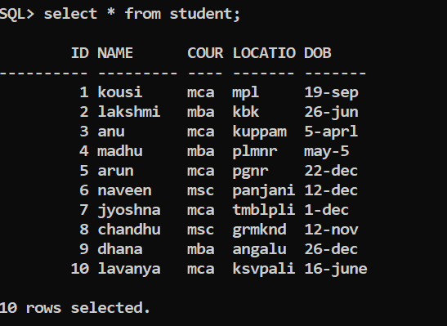

SQL>commit;

Commited.

Employee details

ss SQL>create table employee(id number(3),name varchar(10),salary number(7),designation(4), company(7));

Table created.

SQL>: insert into employee values(&id,'&name','&salary','&designation','&company');

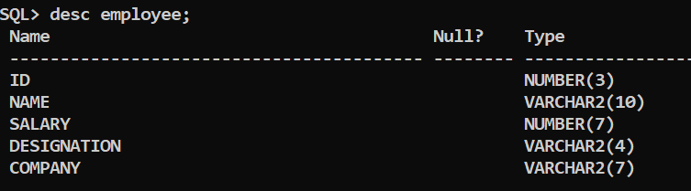

SQL>> insert into employee values(&id,'&name','&salary','&designation','&company');

Enter value for id: 1

Enter value for name: kousi

Enter value for salary: 100000

Enter value for designation: s\w

Enter value for company: tcs

old 1: insert into employee values(&id,'&name','&salary','&designation','&company')

new 1: insert into employee values(1,'kousi','100000','s\w','tcs')

1 row created

SQL> insert into employee values(&id,'&name','&salary','&designation','&company');

Enter value for id: 2

Enter value for name: lakshmi

Enter value for salary: 90000

Enter value for designation: h\w

Enter value for company: ibm

old 1: insert into employee values(&id,'&name','&salary','&designation','&company')

new 1: insert into employee values(2,'lakshmi','90000','h\w','ibm')

1 row created.

SQL> insert into employee values(&id,'&name','&salary','&designation','&company');

Enter value for id: 3

Enter value for name: anu

Enter value for salary: 80000

Enter value for designation: s\w

Enter value for company: tcs

old 1: insert into employee values(&id,'&name','&salary','&designation','&company')

new 1: insert into employee values(3,'anu','80000','s\w','tcs')

1 row created.

SQL> insert into employee values(&id,'&name','&salary','&designation','&company');

Enter value for id: 4

Enter value for name: madhu

Enter value for salary: 90000

Enter value for designation: hr

Enter value for company: cts

old 1: insert into employee values(&id,'&name','&salary','&designation','&company')

new 1: insert into employee values(4,'madhu','90000','hr','cts')

1 row created.

SQL> insert into employee values(&id,'&name','&salary','&designation','&company');

Enter value for id: 5

Enter value for name: arun

Enter value for salary: 100000

Enter value for designation: mngr

Enter value for company: infosys

old 1: insert into employee values(&id,'&name','&salary','&designation','&company')

new 1: insert into employee values(5,'arun','100000','mngr','infosys')

1 row created.

SQL> insert into employee values(&id,'&name','&salary','&designation','&company');

Enter value for id: 6

Enter value for name: naveen

Enter value for salary: 80000

Enter value for designation: s\w

Enter value for company: ibm

old 1: insert into employee values(&id,'&name','&salary','&designation','&company')

new 1: insert into employee values(6,'naveen','80000','s\w','ibm')

1 row created.

SQL> insert into employee values(&id,'&name','&salary','&designation','&company');

Enter value for id: 7

Enter value for name: lavanya

Enter value for salary: 100000

Enter value for designation: s\w

Enter value for company: tcs

old 1: insert into employee values(&id,'&name','&salary','&designation','&company')

new 1: insert into employee values(7,'lavanya','100000','s\w','tcs')

1 row created.

SQL> insert into employee values(&id,'&name','&salary','&designation','&company');

Enter value for id: 8

Enter value for name: gangully

Enter value for salary: 85000

Enter value for designation: hr

Enter value for company: asntr

old 1: insert into employee values(&id,'&name','&salary','&designation','&company')

new 1: insert into employee values(8,'gangully','85000','hr','asntr')

1 row created.

SQL> insert into employee values(&id,'&name','&salary','&designation','&company');

Enter value for id: 9

Enter value for name: dhana

Enter value for salary: 100000

Enter value for designation: s\w

Enter value for company: tcs

old 1: insert into employee values(&id,'&name','&salary','&designation','&company')

new 1: insert into employee values(9,'dhana','100000','s\w','tcs')

1 row created.

SQL> insert into employee values(&id,'&name','&salary','&designation','&company');

Enter value for id: 10

Enter value for name: kiran

Enter value for salary: 80000

Enter value for designation: s\w

Enter value for company: ibm

old 1: insert into employee values(&id,'&name','&salary','&designation','&company')

new 1: insert into employee values(10,'kiran','80000','s\w','ibm')

1 row created.

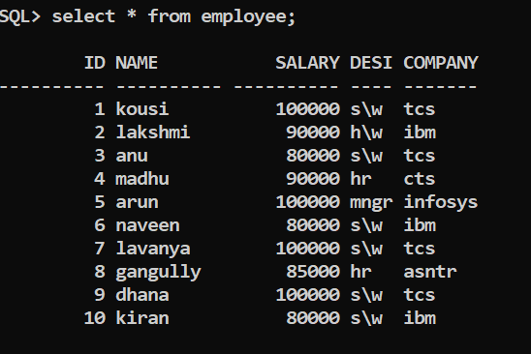

SQL> select id,name from employee where name='madhu';

ID NAME

4 madhu

SQL> delete from employee where name='naveen';

1 row deleted.

SQL> drop table employee;

Table dropped.

SQL> create table vendor(id number(3),name varchar(15),location varchar(10),age number(3));

Table created.

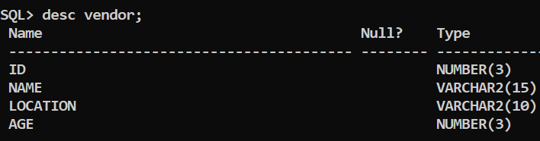

SQL> insert into vendor values(&id,'&name','&location',&age);

Enter value for id: 1

Enter value for name: kousi

Enter value for location: mpl

Enter value for age: 20

old 1: insert into vendor values(&id,'&name','&location',&age)

new 1: insert into vendor values(1,'kousi','mpl',20)

1 row created.

SQL> insert into vendor values(&id,'&name','&location',&age);

Enter value for id: 2

Enter value for name: anu

Enter value for location: kuppam

Enter value for age: 21

old 1: insert into vendor values(&id,'&name','&location',&age)

new 1: insert into vendor values(2,'anu','kuppam',21)

1 row created.

SQL> insert into vendor values(&id,'&name','&location',&age);

Enter value for id: 3

Enter value for name: arun

Enter value for location: girijapur

Enter value for age: 22

old 1: insert into vendor values(&id,'&name','&location',&age)

new 1: insert into vendor values(3,'arun','girijapur',22)

1 row created.

SQL> insert into vendor values(&id,'&name','&location',&age);

Enter value for id: 4

Enter value for name: madhu

Enter value for location: plmnr

Enter value for age: 21

old 1: insert into vendor values(&id,'&name','&location',&age)

new 1: insert into vendor values(4,'madhu','plmnr',21)

1 row created.

SQL> insert into vendor values(&id,'&name','&location',&age);

Enter value for id: 5

Enter value for name: naveen

Enter value for location: panjani

Enter value for age: 22

old 1: insert into vendor values(&id,'&name','&location',&age)

new 1: insert into vendor values(5,'naveen','panjani',22)

1 row created.

SQL> insert into vendor values(&id,'&name','&location',&age);

Enter value for id: 6

Enter value for name: lakshmi

Enter value for location: bkt

Enter value for age: 21

old 1: insert into vendor values(&id,'&name','&location',&age)

new 1: insert into vendor values(6,'lakshmi','bkt',21)

1 row created.

SQL> insert into vendor values(7,'gangully','mpl',20);

1 row created.

SQL> insert into vendor values(8,'dhana','plmnr',20);

1 row created.

SQL> insert into vendor values(9,'chandhu','kuppam',21);

1 row created.

SQL> insert into vendor values(10,'jyo','kdri',21);

1 row created.

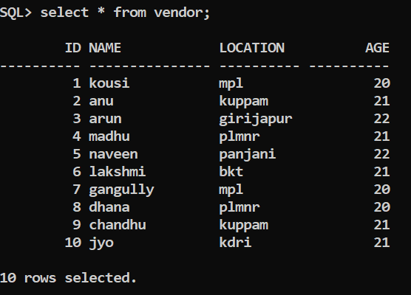

SQL> create table item(id number(3),name varchar(10),quantity varchar(9),prise number(10));

Table created.

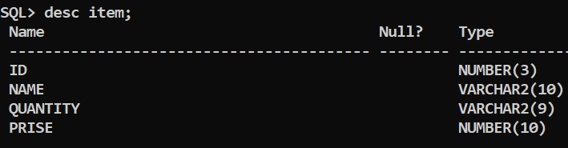

SQL> insert into item values(&id,'&name','&quantity',&prise);

Enter value for id: 1

Enter value for name: sugar

Enter value for quantity: 10kg

Enter value for prise: 500

old 1: insert into item values(&id,'&name','&quantity',&prise)

new 1: insert into item values(1,'sugar','10kg',500)

1 row created.

SQL> insert into item values(&id,'&name','&quantity',&prise);

Enter value for id: 2

Enter value for name: salt

Enter value for quantity: 15kg

Enter value for prise: 200

old 1: insert into item values(&id,'&name','&quantity',&prise)

new 1: insert into item values(2,'salt','15kg',200)

1 row created.

SQL> insert into item values(&id,'&name','&quantity',&prise);

Enter value for id: 3

Enter value for name: groundnut

Enter value for quantity: 24kg

Enter value for prise: 755

old 1: insert into item values(&id,'&name','&quantity',&prise)

new 1: insert into item values(3,'groundnut','24kg',755)

1 row created.

SQL> insert into item values(&id,'&name','&quantity',&prise);

Enter value for id: 4

Enter value for name: buscits

Enter value for quantity: 7kg

Enter value for prise: 888

old 1: insert into item values(&id,'&name','&quantity',&prise)

new 1: insert into item values(4,'buscits','7kg',888)

1 row created.

SQL> insert into item values(&id,'&name','&quantity',&prise);

Enter value for id: 5

Enter value for name: chocolates

Enter value for quantity: 50kg

Enter value for prise: 10000

old 1: insert into item values(&id,'&name','&quantity',&prise)

new 1: insert into item values(5,'chocolates','50kg',10000)

1 row created.

SQL> insert into item values(&id,'&name','&quantity',&prise);

Enter value for id: 6

Enter value for name: honey

Enter value for quantity: 10kg

Enter value for prise: 900

old 1: insert into item values(&id,'&name','&quantity',&prise)

new 1: insert into item values(6,'honey','10kg',900)

1 row created.

SQL> insert into item values(&id,'&name','&quantity',&prise);

Enter value for id: 7

Enter value for name: shampoo

Enter value for quantity: 3kg

Enter value for prise: 700

old 1: insert into item values(&id,'&name','&quantity',&prise)

new 1: insert into item values(7,'shampoo','3kg',700)

1 row created.

SQL> insert into item values(&id,'&name','&quantity',&prise);

Enter value for id: 8

Enter value for name: freedomoil

Enter value for quantity: 25kg

Enter value for prise: 2500

old 1: insert into item values(&id,'&name','&quantity',&prise)

new 1: insert into item values(8,'freedomoil','25kg',2500)

1 row created.

SQL> insert into item values(&id,'&name','&quantity',&prise);

Enter value for id: 9

Enter value for name: parota

Enter value for quantity: 10pkts

Enter value for prise: 550

old 1: insert into item values(&id,'&name','&quantity',&prise)

new 1: insert into item values(9,'parota','10pkts',550)

1 row created.

SQL> insert into item values(&id,'&name','&quantity',&prise);

Enter value for id: 10

Enter value for name: sbja

Enter value for quantity: 1kg

Enter value for prise: 900

old 1: insert into item values(&id,'&name','&quantity',&prise)

new 1: insert into item values(10,'sbja','1kg',900)

1 row created.

